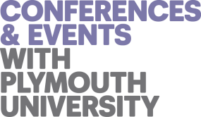 | 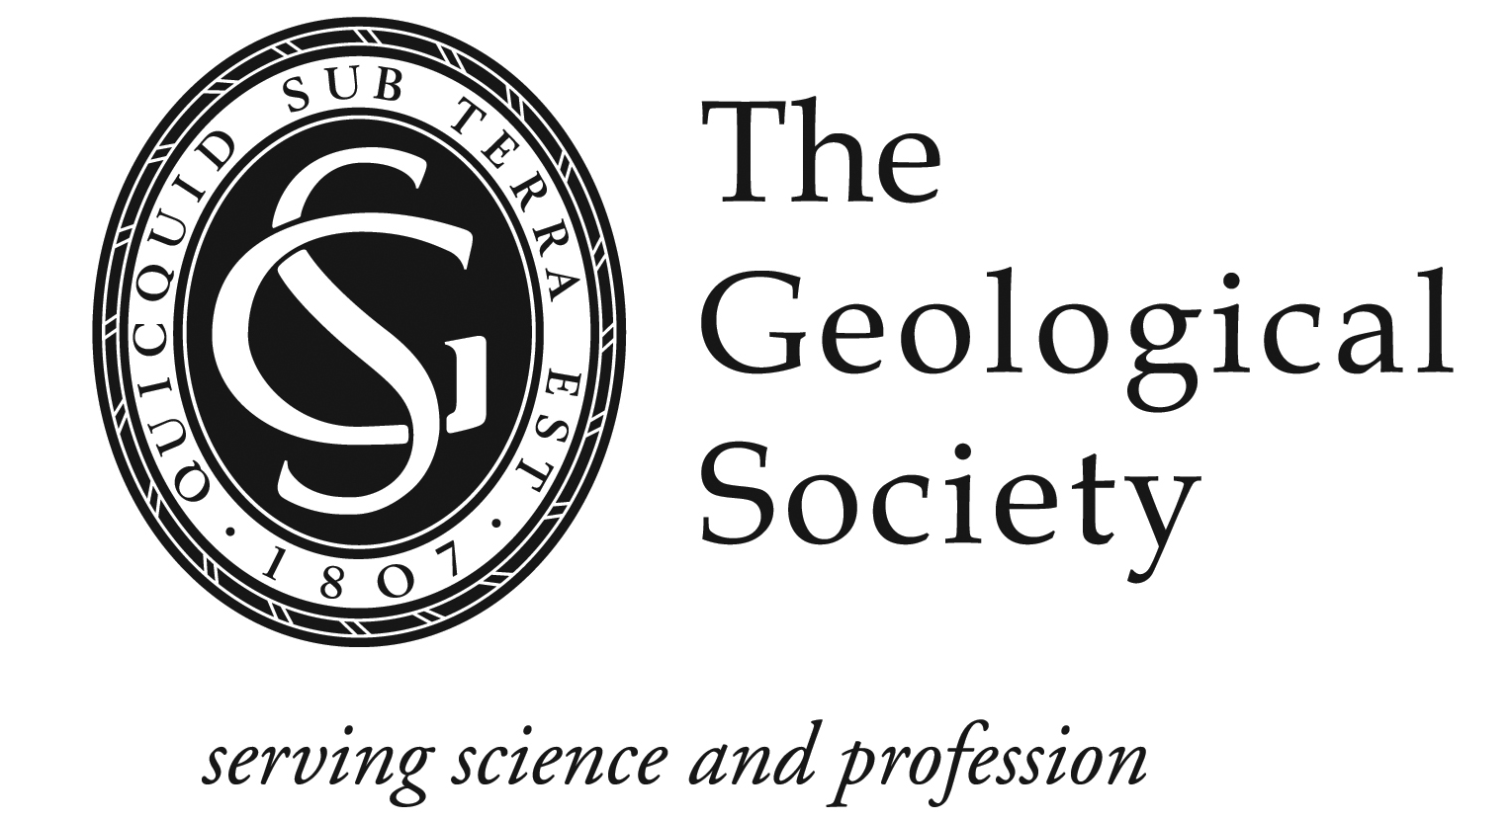 | 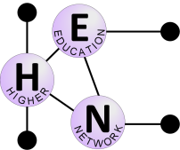

Geological Society of London Higher Education Network Annual Meeting 2018

‘The Way to Work’: Graduate Employability in the Geosciences

Programme: 16th January 2018: ORAL PRESENTATIONS

09:00 | Registration and coffee
09:30 | Welcome and introduction  Mark Anderson
09:40 | KEYNOTE 1: Building the skills and capabilities to succeed in a digital world  Simon White (Digital Director, Atkins)
10:30 | Simple steps to improve employability – one tutors perspective  Stephen Penn (University of Portsmouth)
10:50 | COFFEE
11:20 | The changing world of geoscience graduate employment: a Plymouth University perspective 2007-2017  Martin Stokes (University of Plymouth)
11:40 | Graduate recruitment. A petroleum industry and academic perspective.  Tim Pritchard (University of Leicester)
12:00 | Discovering what makes students employable with insights from a professional advisory board  Linda Kerstein & Wyn Williams (University of Edinburgh)
12:20 | Enhancing employability attributes for environmental science graduates  Charlotte Braungardt et al. (University of Plymouth)
12:40 | LUNCH and Geol Soc HEN AGM
13:50 | KEYNOTE 2: Making GEES students employable: a personal perspective  James Griffiths (Emeritus Profession and Engineering Geology Consultant)
14:40 | Exploring barriers to employability for GEES students with disabilities  Alison Stokes et al. (University of Plymouth, University of Leeds, Open University)
15:00 | COFFEE
15:20 | Geospatial Software and Services: A review of recent developments  Tom Armitage (EDINA, University of Edinburgh)
15:40 | Engineering Geology Industrial Bursary Scheme - a pathway to employability  Nick Koor (University of Portsmouth)
16:00 | Plenary / discussion
Programme: 17th January 2018: INTERACTIVE SESSIONS

09:30 | Can authentic assessment improve student engagement and employability skills?  Jane Collings and Priska Schoenborn (University of Plymouth)
10:30 | Bringing the 3D world into the classroom  Malcolm Whitworth (University of Portsmouth)
11:30 | COFFEE
12:00 | Careers professionals and academics: Working together to increase employability  Claire Guy (University of Plymouth)
13:00 | LUNCH
14:00 | The joys of teamworking: experiences and discussion (temporary title!)  Alan Boyle (University of Liverpool) & Gawen Jenkins (University of Leicester)
15:00 | Wrap-up and close

